Aquatic Macroinvertebrate Species List for River Roeburn

July 11th 2011

Sharon Flint BSc

Flintsentomologists@btinternet.com

Aim

This initial work was to carry out a survey of the river Roeburn. A list of aquatic macroinvertebrate species would be generated for each station. The data would provide a relatively accurate picture of what species/community assemblages are to be found in the river, both above and below the proposed installation at the time of sampling.

Fig. 1, Site map provided by client.

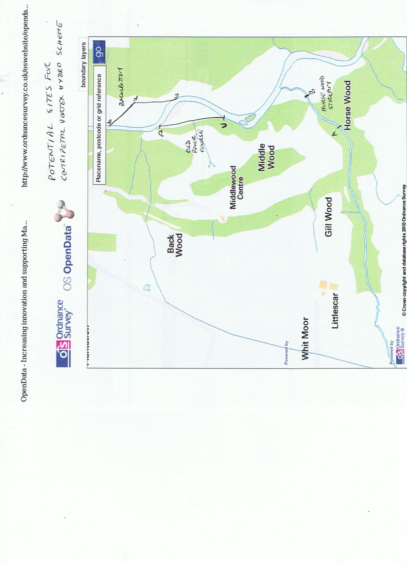

Sampling Stations

Sampling was carried out on the 11th of July 2011. The downstream samples were taken adjacent to the old site of Backsbottom farm (below point D on the map, Fig.1) (NGR:SD607655). The upstream samples were taken from the stretch of river between Horsewood Stream and the island (in the river bend), above the proposed hydro installation (above point C on the map, Fig.1) (NGR:SD606658).

Methods

Five replicate samples were taken along a 20 metre reach of the river both above and below the proposed hydro installation. A timed three minute kick sample using a standard pond net was employed at each station and the three minutes of time divided between identified mesohabitats. This was followed at each station by a timed 1 minute search of stones and cobbles. This method allows all available habitats to be sampled and the use of replicate samples increases the probability of capturing most of the available macroinvertebrates. The contents of the pond net were transferred to a white tray containing river water. This was then searched by hand and animals were collected into labelled jars of 70% alcohol and returned to the lab for identification.

Results

The presence of each taxon identified is presented in Table 1 below.

Discussion

It is important to note that the data provide only a snapshot of the community on a single date. At this time of year a significant proportion of the insect species with an aerial adult stage will have left the water. These animals are not, therefore, available for identification and inclusion in the data set. There are also, at this time of year, many very young larvae, which are impossible to identify to species level, for example, very early instar cased caddis larvae belonging to the Family Limnephilidae cannot be identified any further.

Recommendations for future surveys

It is important that any future work be carried out over three seasons; spring, summer and autumn using the methods here employed. This comprehensive approach will ensure that the majority of macroinvertebrates that reside in the river all year will be found and encompassed into the data set. This approach will give a better understanding of the effects that any hydro scheme has had on the macroinvertebrate community assemblage.



Table 1. List of taxa identified from each station